

UNIVERSITY OF THE WESTERN CAPE
TUTORIAL 1

WEEK 2 (24 – 28 aug)

INFORMATION SYSTEMS
244

Student Surname , Name : Batyi, Mbasa
Student Number : 4540469
Group : 01

p

1 | PL/SQL
 | 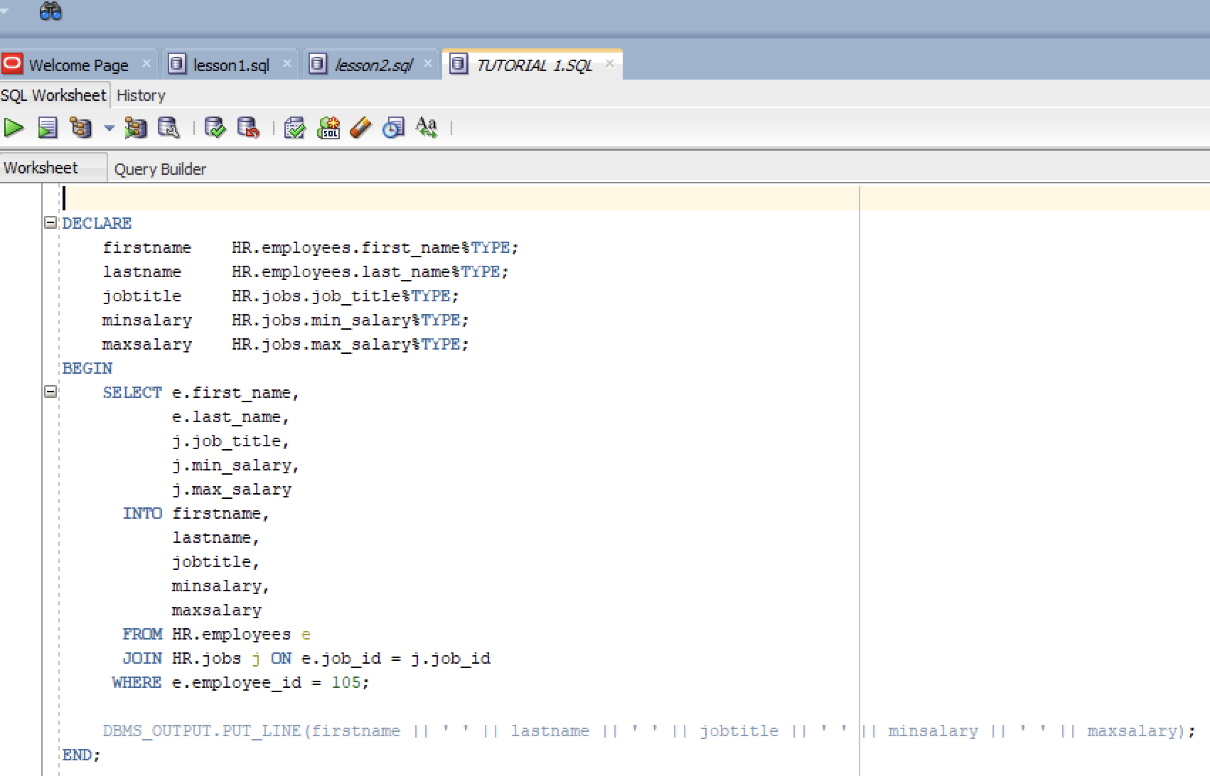
2 | Output
 | 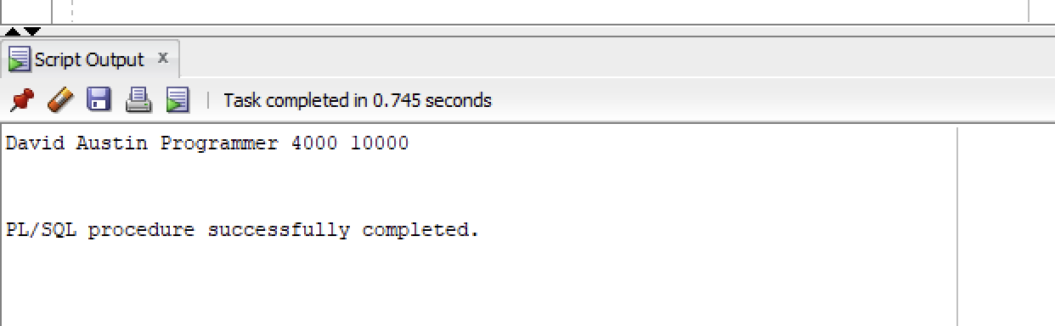

index.php file
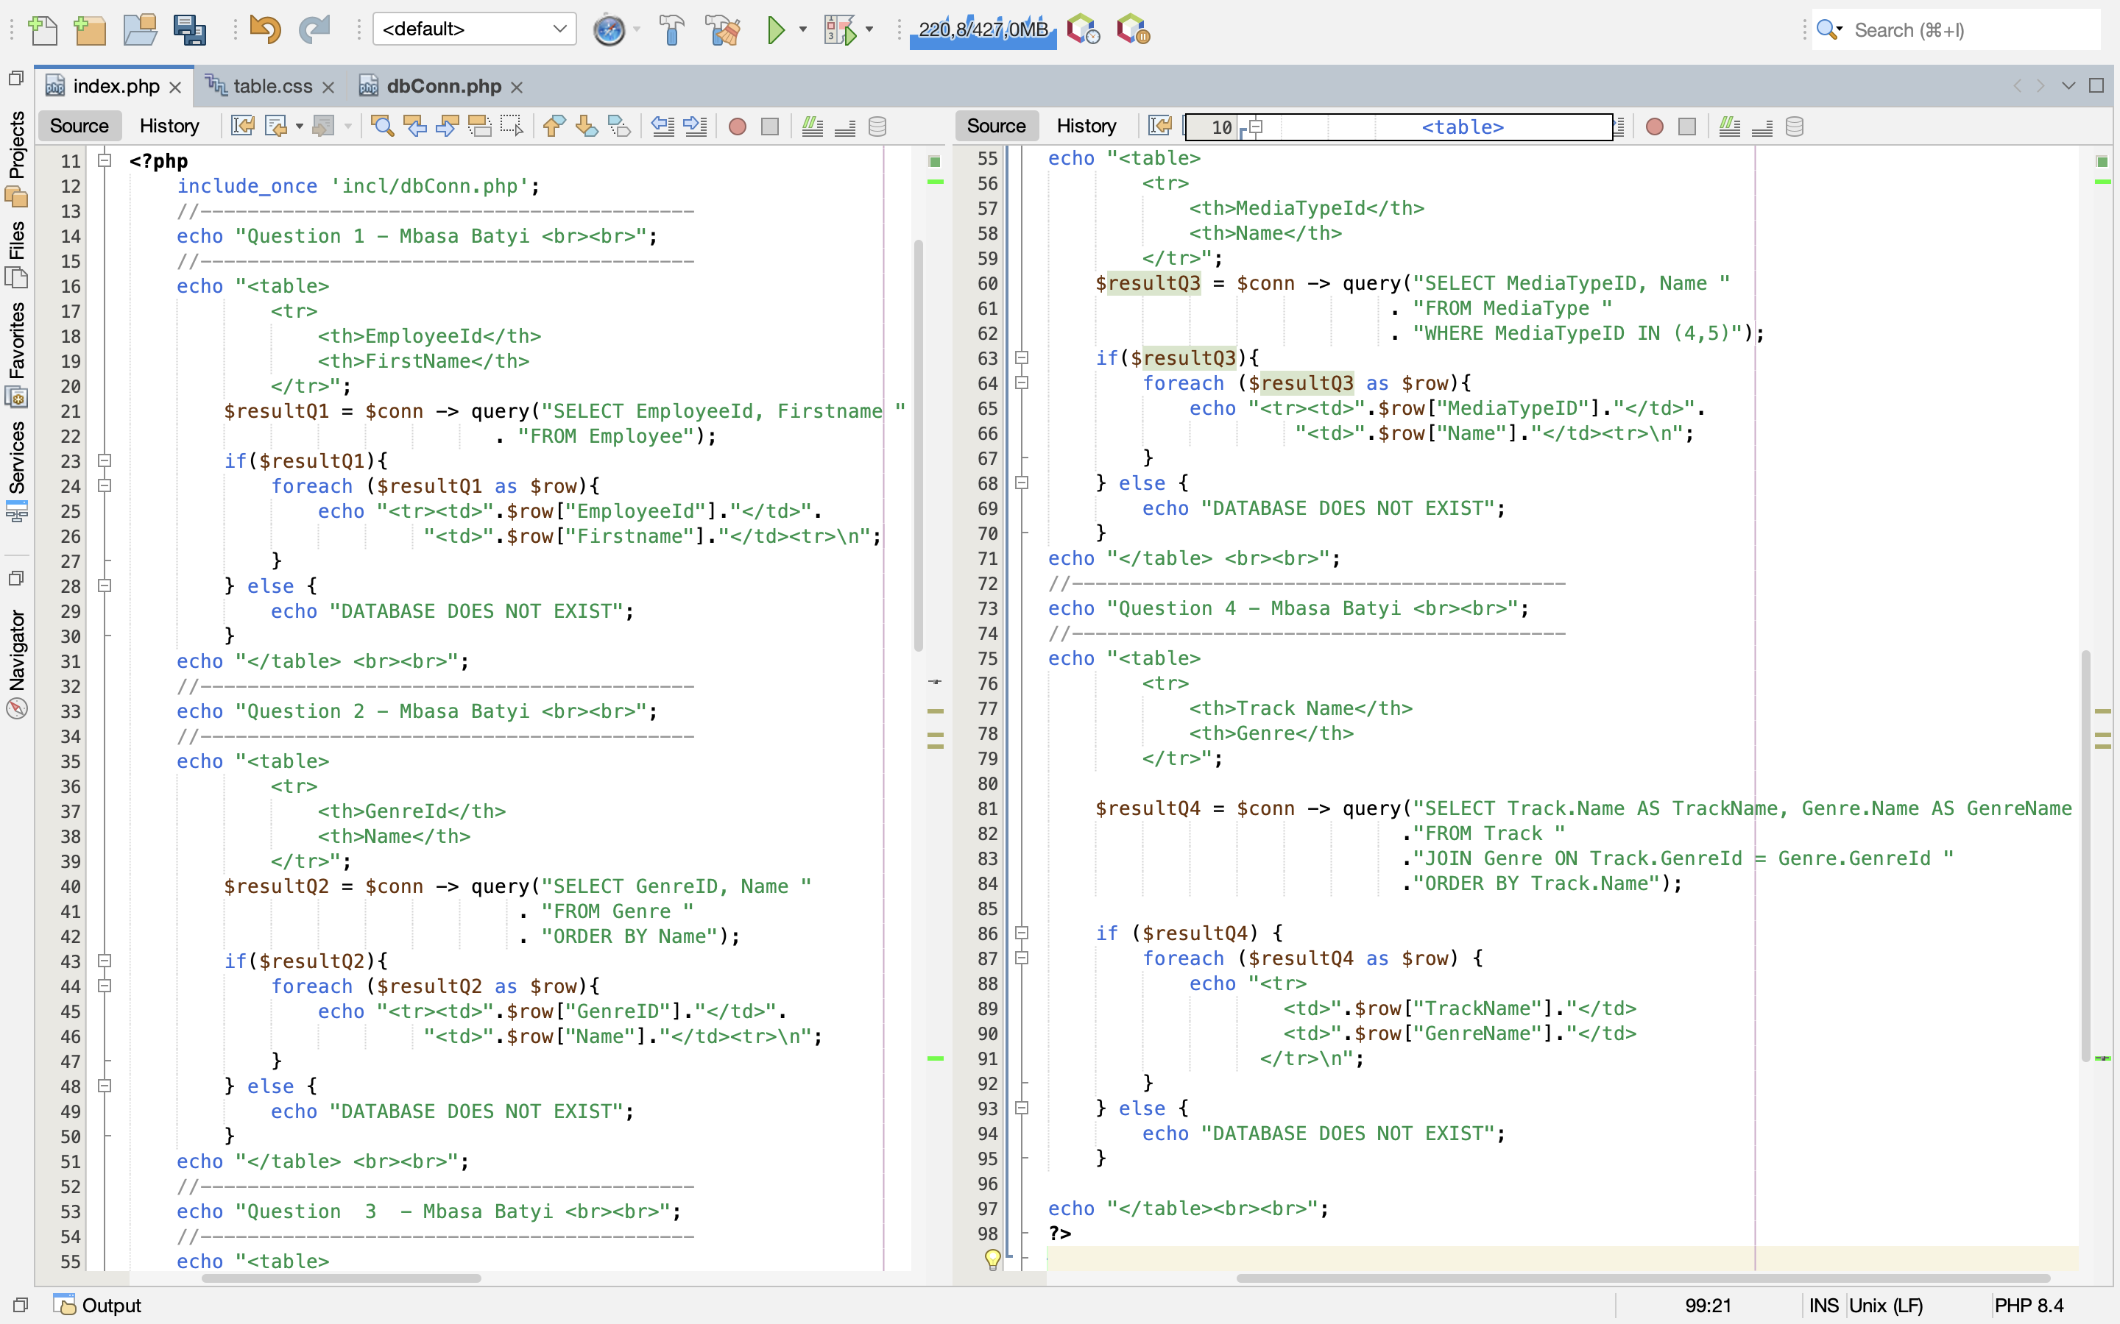
dbConn.php file | table.css file
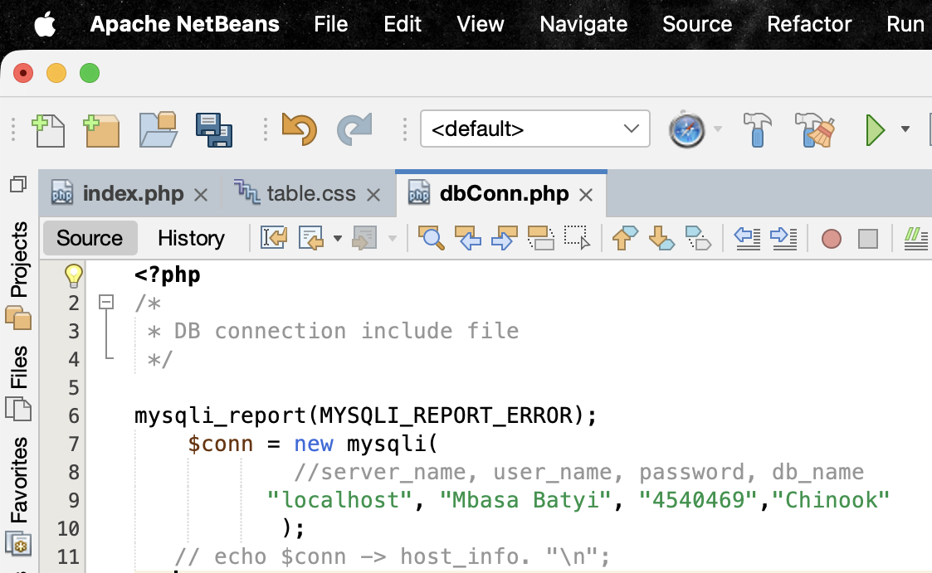 | 